**PHP Date & Time Function with Example**

**What is PHP Date Function?**

PHP date function is an in-built function that simplify working with date data types. The PHP date function is used to format a date or time into a human readable format. It can be used to display the date of article was published. record the last updated a data in a database.

**In this tutorial, you will learn-**

* [PHP Date Syntax & Example](https://www.guru99.com/php-date-functions.html#3)
* [What is a TimeStamp?](https://www.guru99.com/php-date-functions.html#4)
* [Getting a list of available time zone identifiers](https://www.guru99.com/php-date-functions.html#5)
* [PHP set Timezone Programmatically](https://www.guru99.com/php-date-functions.html#6)
* [PHP Mktime Function](https://www.guru99.com/php-date-functions.html#7)
* [PHP Date function](https://www.guru99.com/php-date-functions.html#8)
* [Time parameters](https://www.guru99.com/php-date-functions.html#9)
* [Day parameters](https://www.guru99.com/php-date-functions.html#10)
* [Month Parameters](https://www.guru99.com/php-date-functions.html#11)
* [Year Parameters](https://www.guru99.com/php-date-functions.html#12)

**PHP Date Syntax & Example**

PHP Date the following basic syntax

<?php

date(format,[timestamp]);

?>

HERE,

* “date(…)” is the function that returns the current time on the server.
* “format” is the general format which we want our output to be i.e.;
  + “Y-m-d” for PHP date format YYYY-MM-DD
  + “Y” to display the current year
  + “[timestamp]” is optional. If no timestamp has been provided, PHP will get the use the php current date time on the server.

Let’s look at a basic example that displays the current year.

<?php

echo date("Y");

?>

**Output:**

2018

**What is a TimeStamp?**

 A timestamp is a numeric value in seconds between the current time and value as at 1stJanuary, 1970 00:00:00 Greenwich Mean Time (GMT).

 The value returned by the time function depends on the default time zone.

The default time zone is set in the php.ini file.

It can also be set programmatically using date_default_timezone_set function.

The code below displays the current time stamp

<?php

echo time();

?>

Assuming you saved the file timestamp.php in phptuts folder, browse to the URL **http://localhost/phptuts/timestamp.php**

[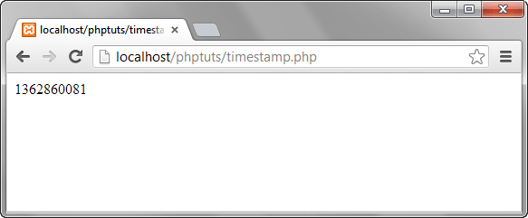](https://www.guru99.com/images/2013/04/timestamp.png)

Note: the value of the timestamp is not a constant. It changes every second.

**Getting a list of available time zone identifiers**

Before we look at how to set the default time zone programmatically, let’s look at how to get a list of supported time zones.

<?php

$timezone_identifiers = DateTimeZone::listIdentifiers();

foreach($timezone_identifiers as $key => $list){

echo $list . "<br/>";

}

?>

  HERE,

* “$timezone_identifiers = DateTimeZone::listIdentifiers();” calls the listIdentifiers static method of the DateandTime Zone built in class.

The listIdentifiers method returns a list of constants that are assigned to the variable $timezone_identifiers.

* “foreach{…}” iterates through the numeric array and prints the values.

Assuming you saved the file list_time_zones.php in phptuts folder, browse to the URL **http://localhost/phptuts/list_time_zones.php**

[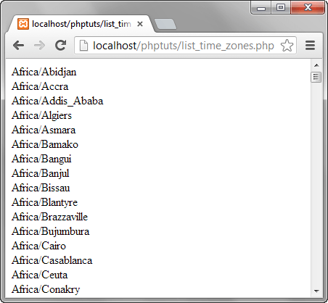](https://www.guru99.com/images/2013/04/list_time_zones.png)

**PHP set Timezone Programmatically**

The date_default_timezone_set function allows you to set the default time zone from a PHP script.

The set time zone will then be used by all date php function scripts. It has the following syntax.

<?php

date_default_timezone_set ( string $timezone_identifier );

?>

HERE,

* “date_default_timezone_set()” is the function that sets the default time zone
* “string $timezone_identifier” is the time zone identifier

The script below displays the time according to the default time zone set in php.ini.

It then changes the default time zone to Asia/Calcutta and displays the time again.

<?php

echo "The time in " . date_default_timezone_get() . " is " . date("H:i:s");

date_default_timezone_set("Asia/Calcutta");

echo "The time in " . date_default_timezone_get() . " is " . date("H:i:s");

?>

  Assuming you have saved the file set_time_zone.php in the phptuts folder, browse to the URL**http://localhost/phptuts/set_time_zone.php**

[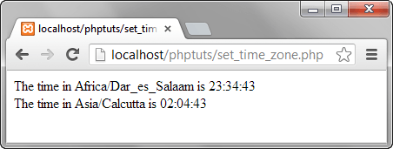](https://www.guru99.com/images/2013/04/timezone.png)

**PHP Mktime Function**

The mktime function returns the timestamp in a[Unix](https://www.guru99.com/unix-linux-tutorial.html)format.

It has the following syntax.

<?php

mktime(hour, minute, second, month, day, year, is_dst);

?>

HERE,

* “mktime(…)” is the make php timestamp function
* “hour” is optional, it is the number of hour
* “minute” is optional, it is the number of minutes
* “second” is optional, it is the number of seconds
* “month” is optional, it is the number of the month
* “day” is optional, it is the number of the day
* “year” is optional, it is the number of the year
* “is_dst” is optional, it is used to determine the day saving time (DST). 1 is for DST, 0 if it is not and -1 if it is unknown.

Let’s now look at an example that creates a timestamp for the date 13/10/2025 using the mktime function.

<?php

echo mktime(0,0,0,10,13,2025);

?>

  HERE,

* “0,0,0” is the hour, minute and seconds respectively.
* “13” is the day of the month
* “10” is the month of the year
* “2025” is the year

**Output:**

1760328000

**PHP Date function reference**

The table below shows the common parameters used when working with the date php function.

**PHP Time parameters**

| **Parameter** | **Description** | **Example** |
| --- | --- | --- |
| “r” | Returns the full date and time | <?php  echo date("r");  ?> |
| “a”,”A” | Returns whether the current time is am or pm, AM or PM respectively | <?php  echo date("a");  echo date("A");  ?> |
| “g”,”G” | Returns the hour without leading zeroes [1 to 12], [0 to 23] respectively | <?php  echo date("g");  echo date("G");  ?> |
| “h”,”H” | Returns the hour with leading zeros [01 to 12],[00 to 23] respectively | <?php  echo date("h");  echo date("H");  ?> |
| “i”,”s” | Returns the minutes/seconds with leading zeroes [00 to 59] | <?php  echo date("i");  echo date("s");  ?> |

**Day parameters**

| **Parameter** | **Description** | **Example** |
| --- | --- | --- |
| “d” | Returns the day of the month with leading zeroes [01 to 31] | <?php  echo date("d");  ?> |
| “j” | Returns the day of the month without leading zeroes [1 to 31] | <?php  echo date("j");  ?> |
| “D” | Returns the first 3 letters of the day name [Sub to Sat] | <?php  echo date("D");  ?> |
| “l” | Returns day name of the week [Sunday to Saturday] | <?php  echo date("l");  ?> |
| “w” | Returns day of the week without leading zeroes [0 to 6] Sunday is represent by zero (0) through to Saturday represented by six (6) | <?php  echo date("w");  ?> |
| “z” | Returns the day of the year without leading spaces [0 through to 365] | <?php  echo date("z");  ?> |

**Month Parameters**

| **Parameter** | **Description** | **Example** |
| --- | --- | --- |
| “m” | Returns the month number with leading zeroes [01 to 12] | <?php  echo date("m");  ?> |
| “n” | Returns the month number without leading zeroes [01 to 12] | <?php  echo date("n");  ?> |
| “M” | Returns the first 3 letters of the month name [Jan to Dec] | <?php  echo date("M");  ?> |
| “F” | Returns the month name [January to December] | <?php  echo date("F");  ?> |
| “t” | Returns the number of days in a month [28 to 31] | <?php  echo date("t");  ?> |

**Year Parameters**

| **Parameter** | **Description** | **Example** |
| --- | --- | --- |
| “L” | Returns 1 if it’s a leap year and 0 if it is not a leap year | <?php  echo date("L");  ?> |
| “Y” | Returns four digit year format | <?php  echo date("Y");  ?> |
| “y” | Returns two (2) digits year format (00 to 99) | <?php  echo date("y");  ?> |

**Summary**

* The date function is used to format the timestamp into a human desired format.
* The timestamp is the number of seconds between the current time and 1st January, 1970 00:00:00 GMT. It is also known as the UNIX timestamp.
* All date functions use the default time zone set in the php.ini file
* The default time zone can also be set programmatically using PHP scripts.